**Module-3: Docker – I Assignment - 3**

You have been asked to:

● Use the saved image in the previous assignment

● Upload this image on Dockerhub

● On a separate machine pull this dockerhub image, and launch it on port 80

● Start the apache2 service

● Verify if you are able to see the apache2 service

Steps done :

Checking for images available

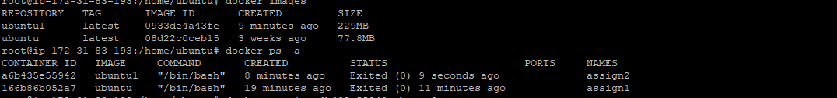

Saving the image ubuntu1 container to create a image out of it 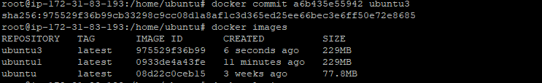

Inorder tp push the image to docker hub. Using the command docker login

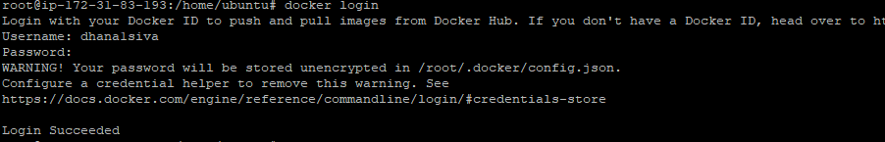

Pushed images to docker hub post tagging .



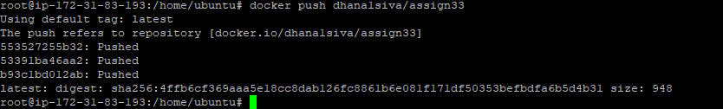

Created new Ubuntu machine

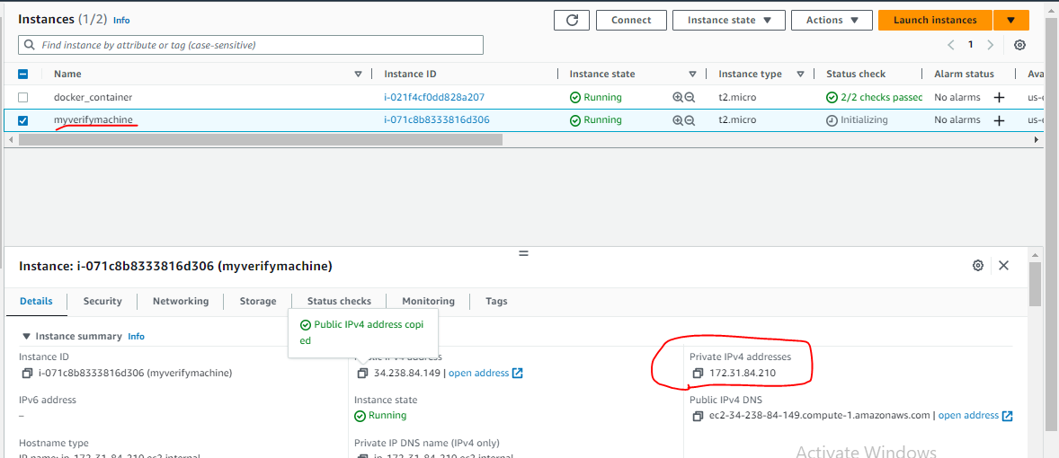

Post installing docker in the new Ubuntu machine

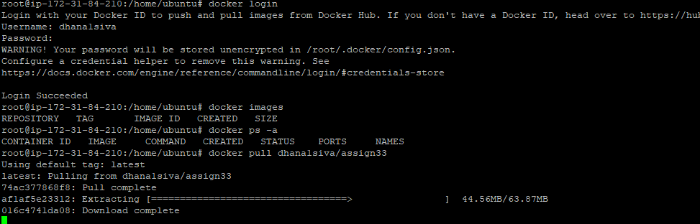

Post docker pull, able to see one image as below



Creating a container out of the above image   


Starting the service

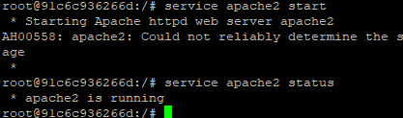

Now webpage is working fine

